Name: Noah Nguyen

R Lab 4: Sampling Distributions

Please answer all the Exercises and the questions from the “On Your Own” section. If you use any graphs or charts to justify your answer, please include them.

Exercise 1: Describe this population distribution. (Include plot.)
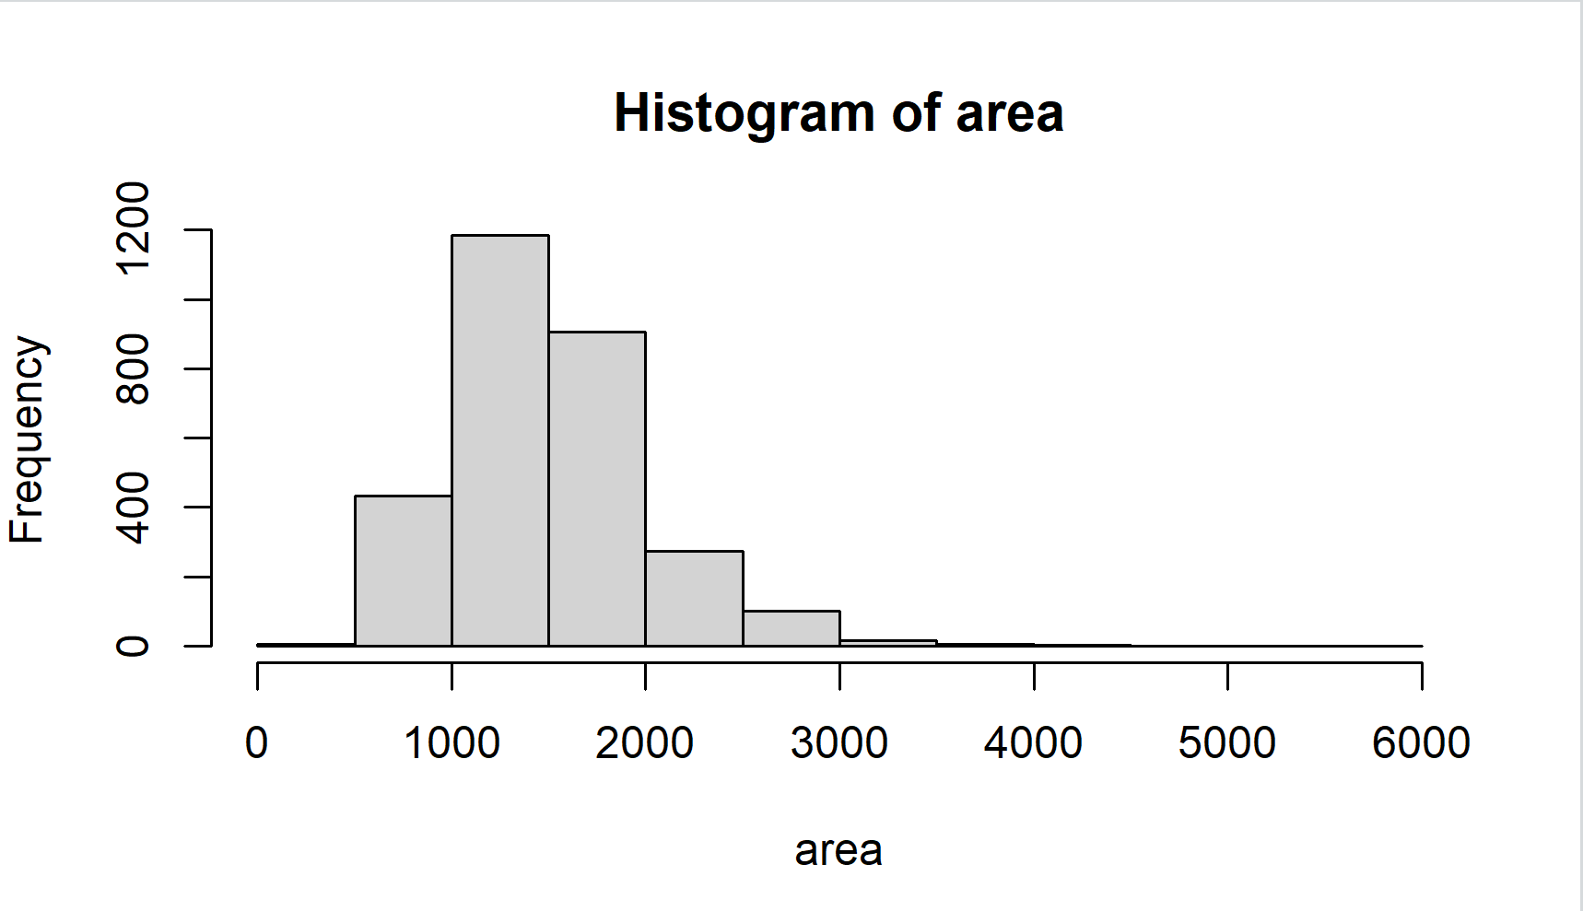
The population distribution is right-skewed.
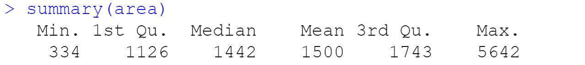
From the summary, the mean is 1500, the median is 1442, and the data range from 334 to 5642.

Exercise 2: Describe the distribution of this sample. How does it compare to the distribution of the population? (Include plots.)
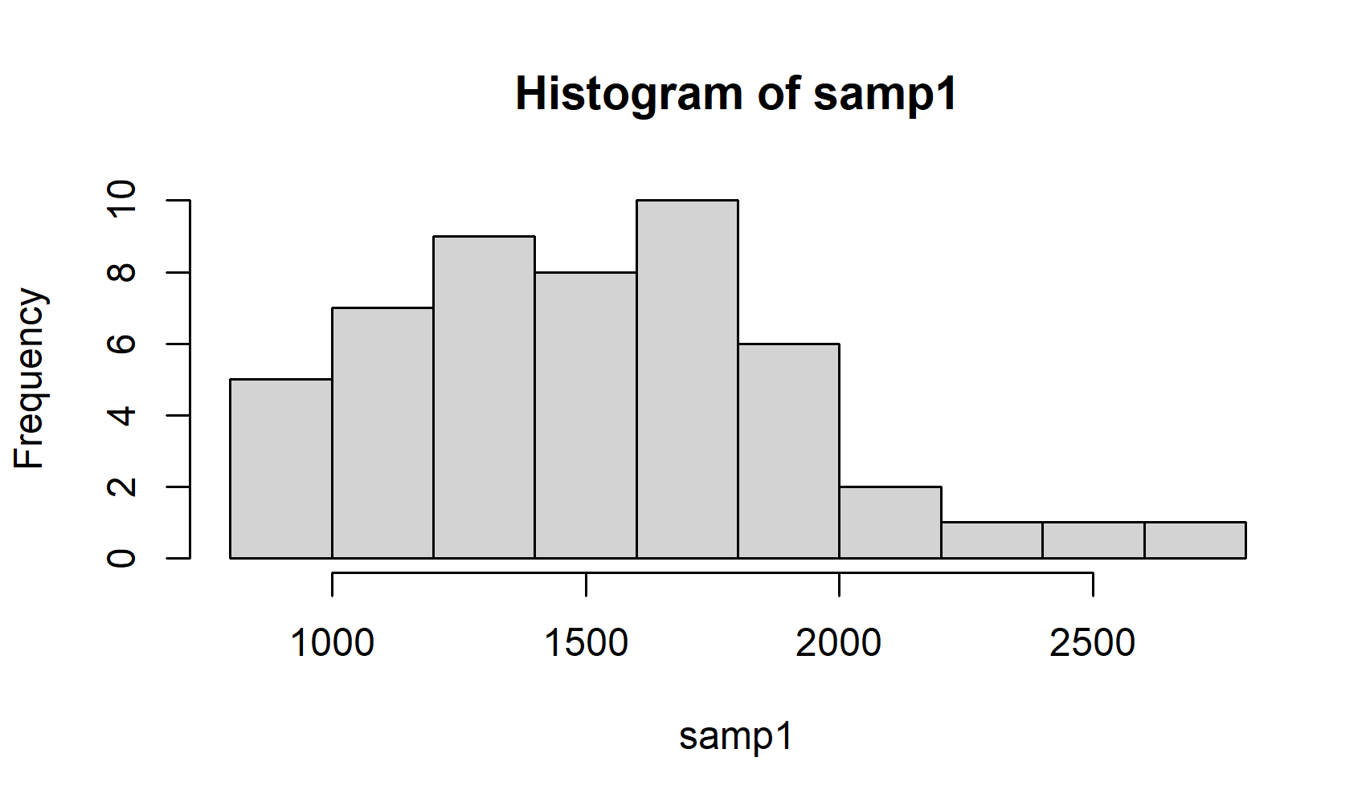
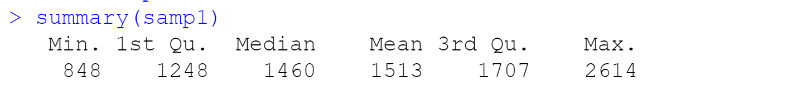
The sample distribution is right-skewed and not normal. From the summary, the mean of the sample is 1513 and the median is 1460, which is close to those of the population. The sample ranges from 848 to 2614.

Exercise 3: Take a second sample, also of size 50, and call it samp2. How does the mean of samp2 compare with the mean of samp1? Suppose we took two more samples, one of size 100 and one of size 1000. Which would you think would provide a more accurate estimate of the population mean?
Take a second sample:
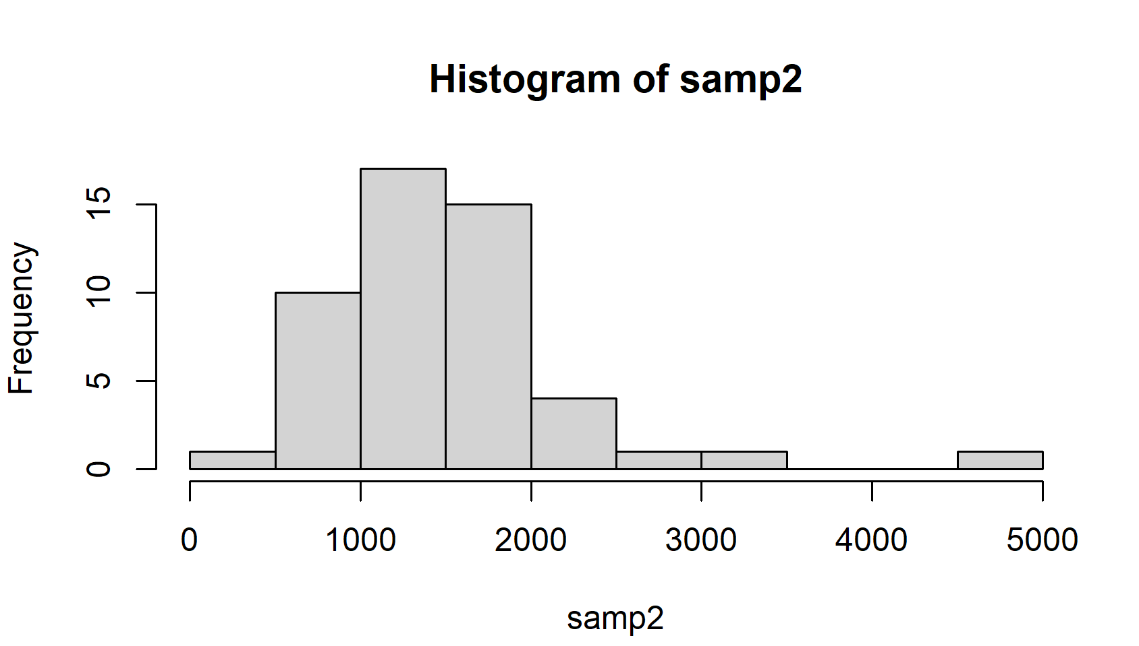
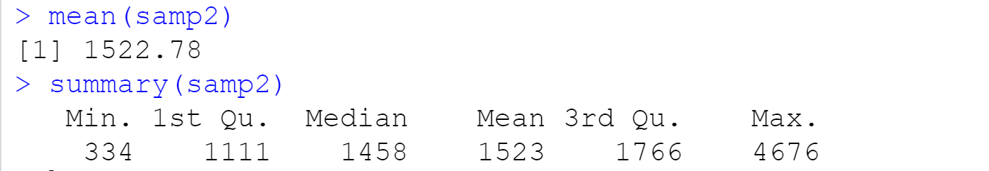
The second sample distribution is also right-skewed. The mean is 1523 and the median is 1458. The distribution ranges from 334 to 4676.
I took another sample of size 100:
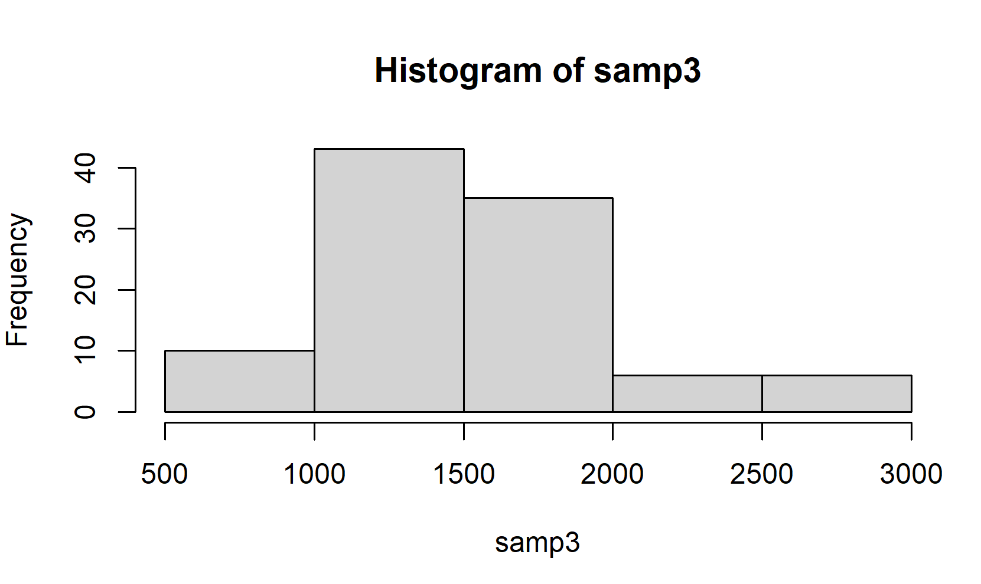
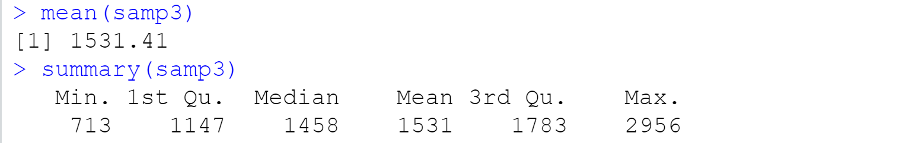
The third sample distribution is also right-skewed with a mean of 1531, a median of 1458, ranging from 713 to 2956.
I took another sample of 1000:
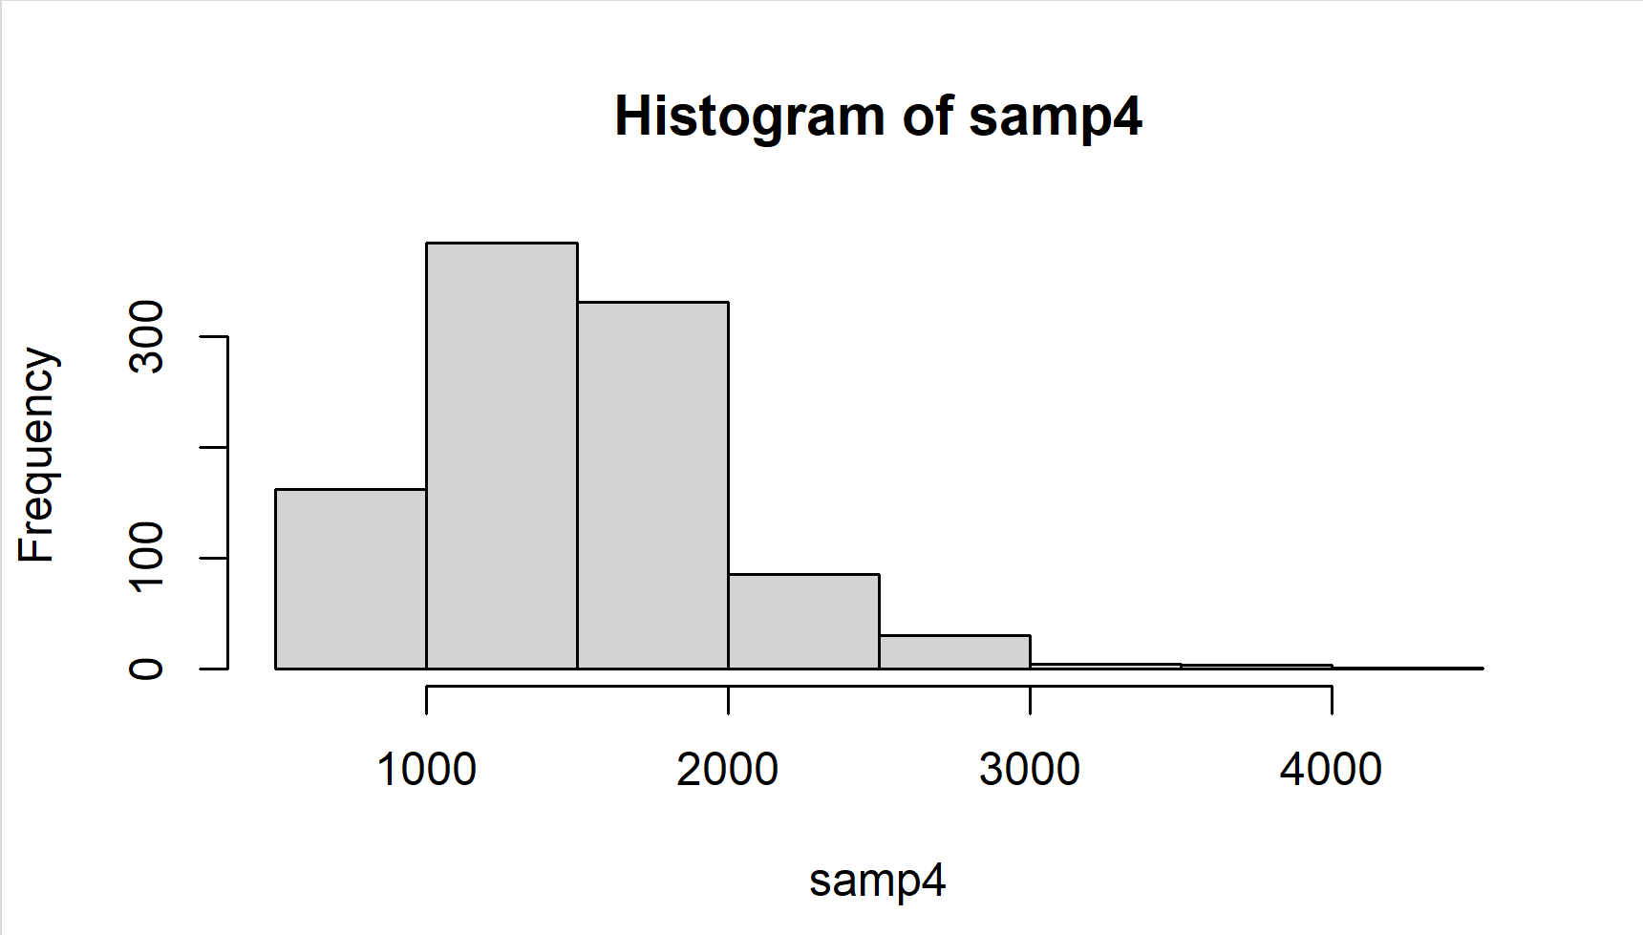
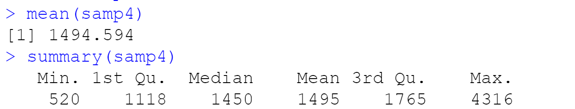
The fourth sample is also right-skewed, with a mean of 1495 and a median of 1450, ranging from 520 to 4316.
Every time we take different samples, we get different mean values. The fourth sample has the mean and median closest to the population mean and sample. This indicates that taking a larger sample size represents the population better.

Exercise 4: How many elements are there in sample_means50? Describe the sampling distribution, and be sure to specifically note its center. (Include plot.) Would you expect the distribution to change if we instead collected 50,000 sample means?
The code to generate sample_means50:
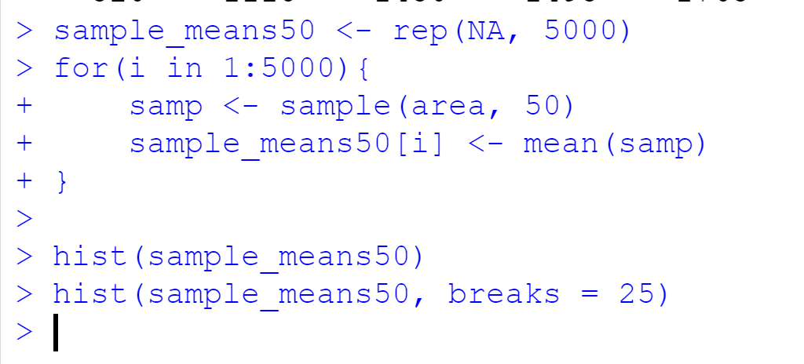
The histogram of sample_means50:
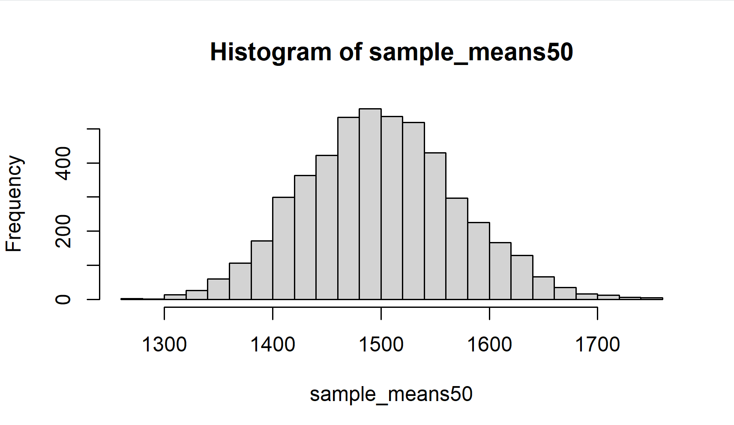
There are 5000 elements in sample_means50. The distribution pretty much has a bell curve. I ran this code to see the mean of sample_means50:
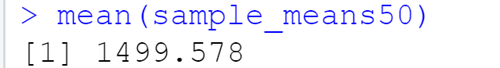
This is really close to the population mean. The mean of sample_means50 is the mean of 5000 elements.
I collect 50,000 samples of size 50:
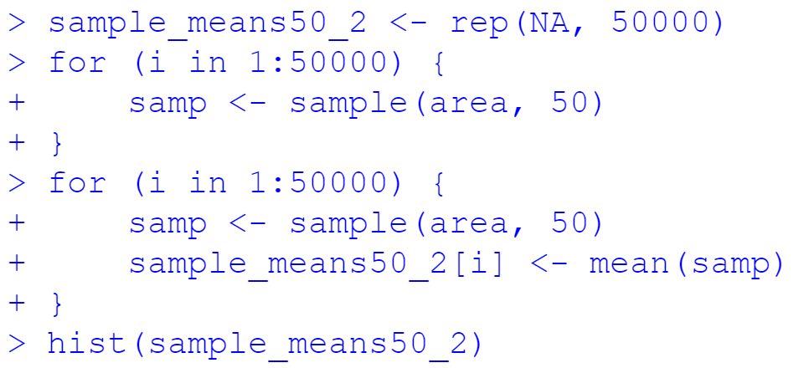
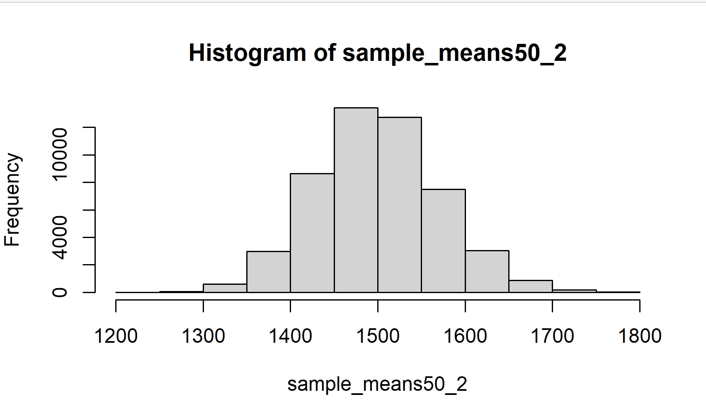
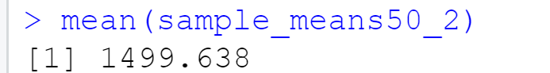
The distribution of 50000 samples does not change and the mean is closer to the population mean.

Exercise 5: To make sure you understand what you’ve done in this loop, try running a smaller version. Initialize a vector of 100 zeros called sample_means_small. Run a loop that takes a sample of size 50 from area and stores the sample mean in sample_means_small, but only iterate from 1 to 100. Print the output to your screen (type sample_means_small into the console and press enter). How many elements are there in this object called sample_means_small? What does each element represent?

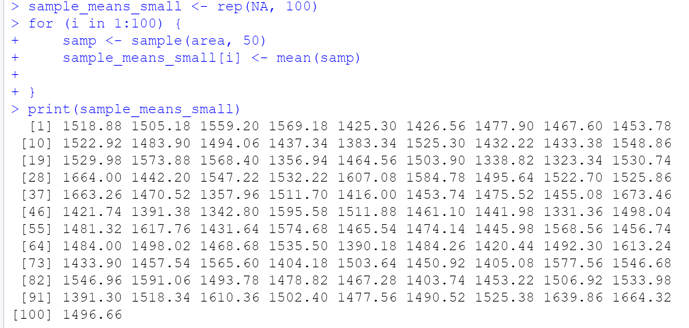
Each element represents the mean of 100 samples of size 50.
Exercise 6: When the sample size is larger, what happens to the center? What about the spread? (Include all plots.)
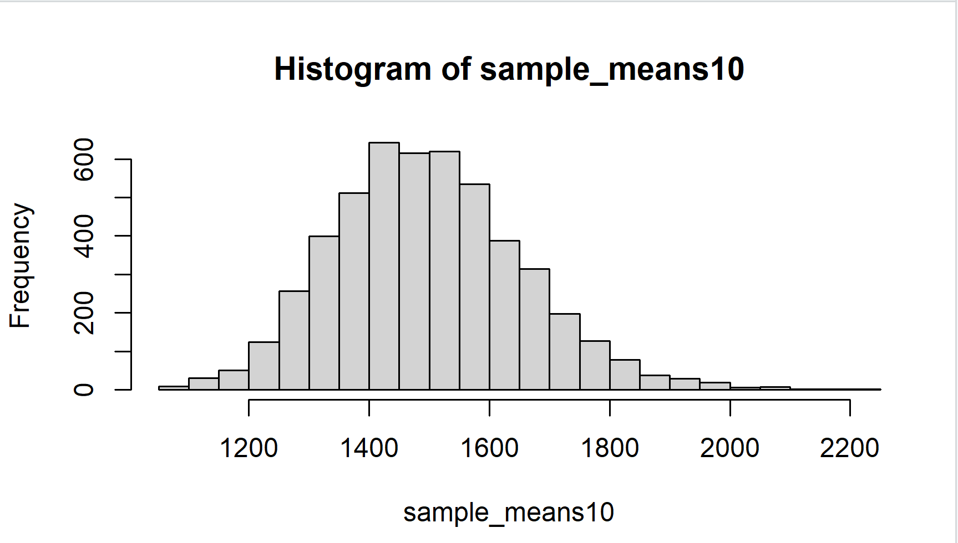
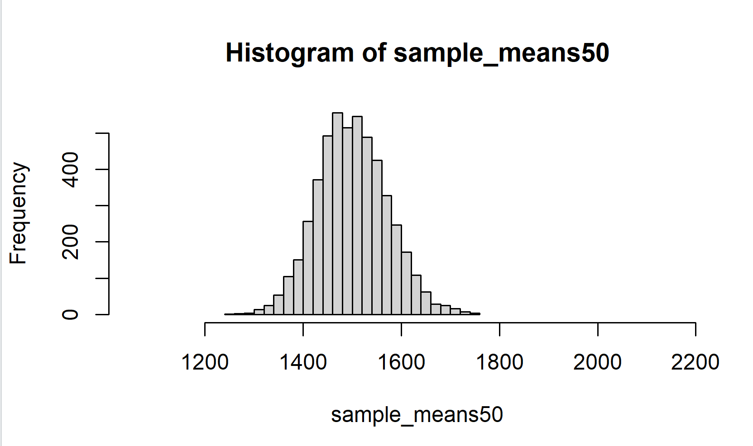
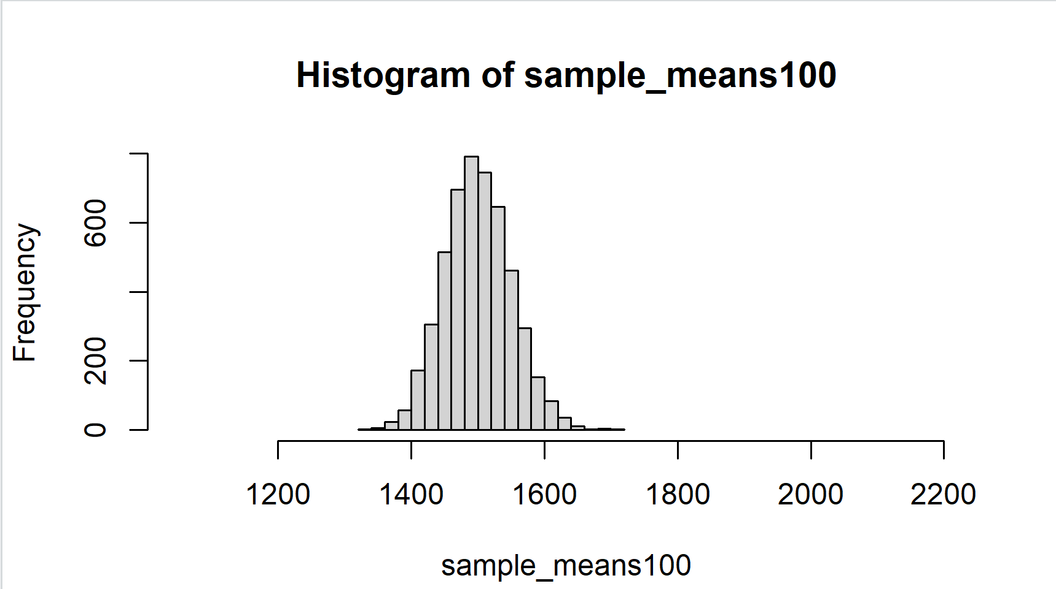
When the sample size is larger, the spread is smaller, and the mean gets closer to the population mean. The center is located closer to the mean.
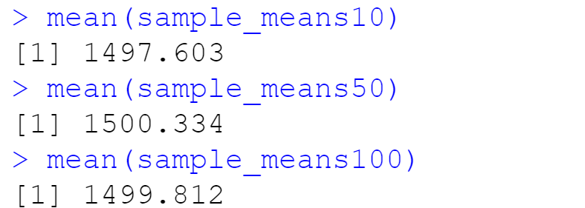

On Your Own:
1) Take a random sample of size 50 from price. Using this sample, what is your best point estimate of the population mean?
The code to take a random sample of size 50 from price:
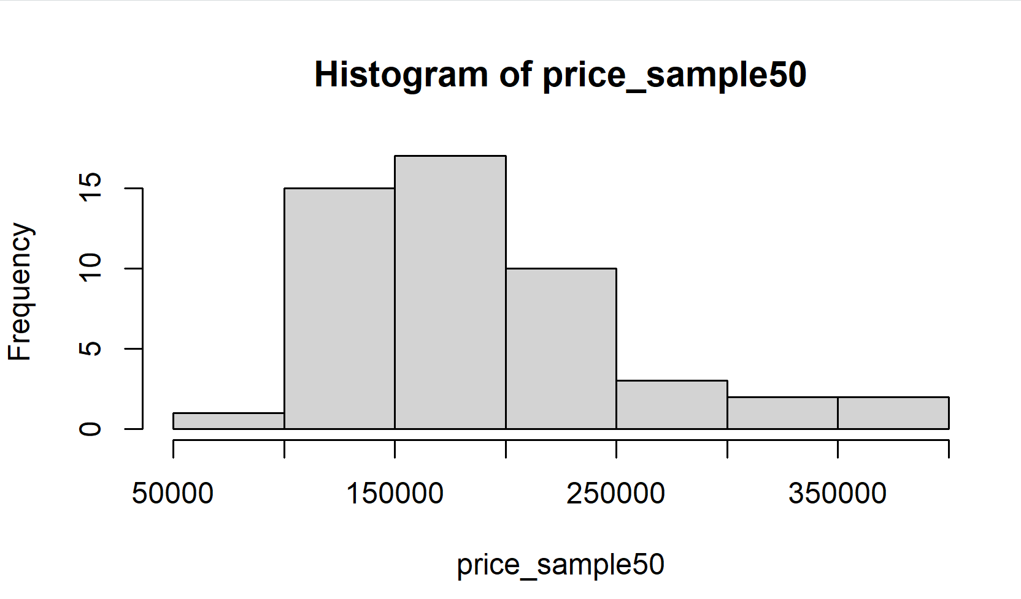
My best point of population mean estimate is 180,000.
2) Since you have access to the population, simulate the sampling distribution for ${\overline{x}}_{price}$ by taking 5000 samples from the population of size 50 and computing 5000 sample means. Store these means in a vector called sample_means50. Plot the data, then describe the shape of this sampling distribution. Based on this sampling distribution, what would you guess the mean home price of the population to be? Finally, calculate and report the population mean. (Include plot.)

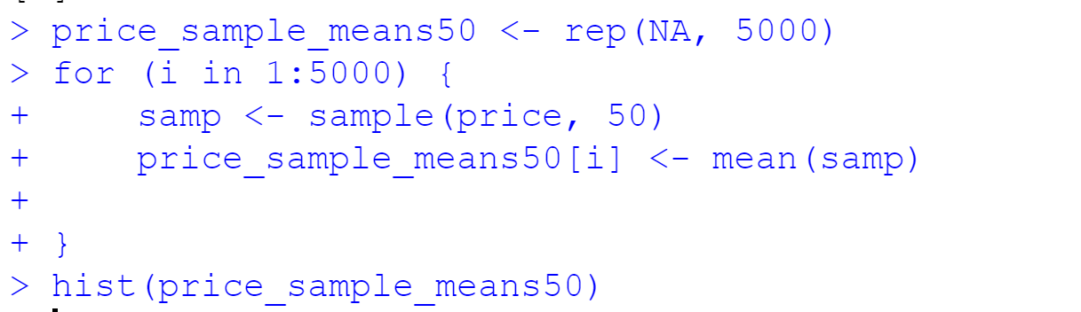
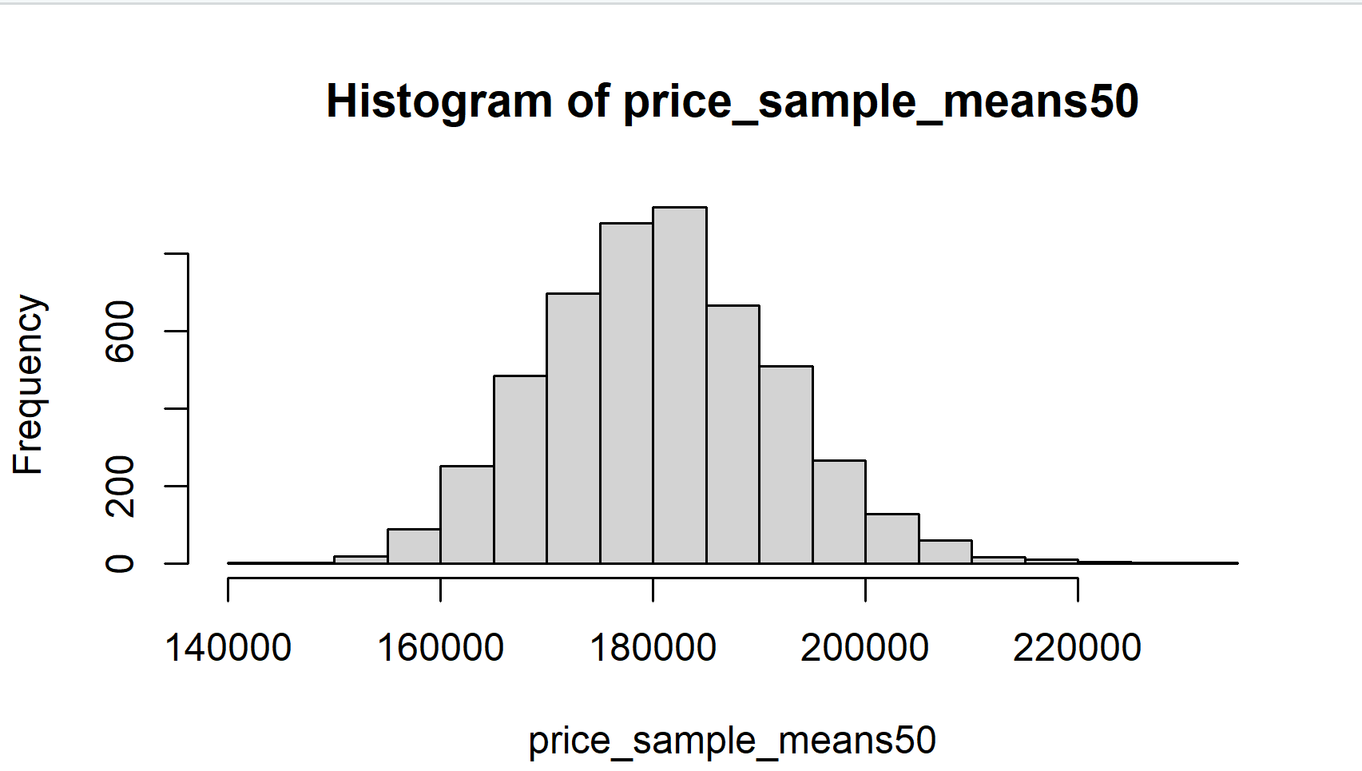
The sample mean is
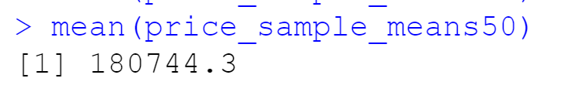
The population mean is
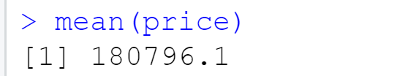

3) Change your sample size from 50 to 150, then compute the sampling distribution using the same method as above, and store these means in a new vector called sample_means150. Describe the shape of this sampling distribution, and compare it to the sampling distribution for a sample size of 50. Based on this sampling distribution, what would you guess to be the mean sale price of homes in Ames? (Include plot.)
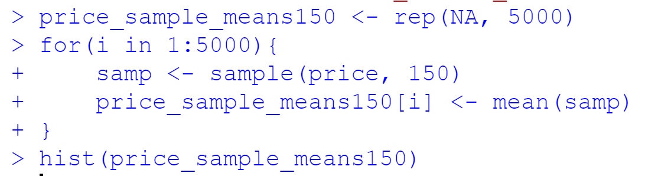
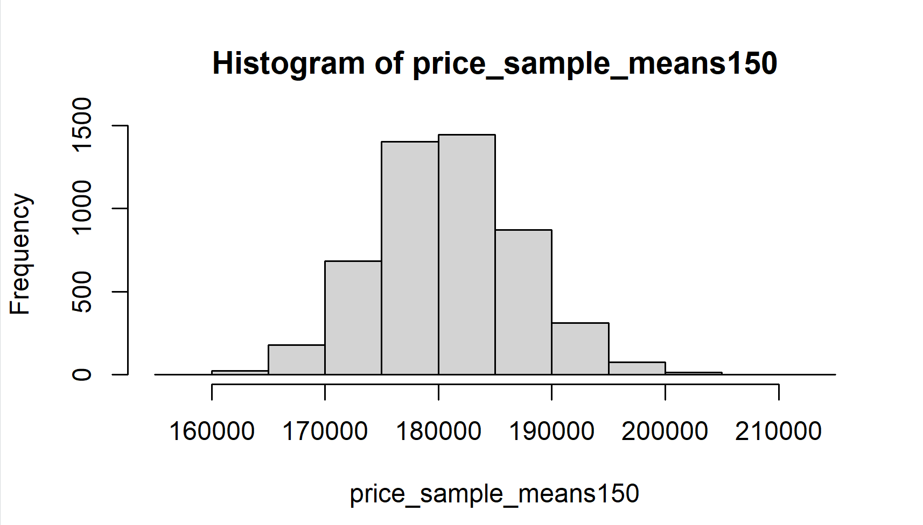
The sample mean is
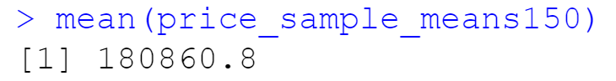
This sample mean is closer to the population mean.

4) Of the sampling distributions from 2 and 3, which has a smaller spread? If we’re concerned with making estimates that are more often close to the true value, would we prefer a distribution with a large or small spread?
The sampling distribution from 3 has a smaller spread. If we’re concerned with making estimates that are more often close to the true value, we prefer a distribution with a smaller spread (larger sample size). The larger the sample size, the smaller the spread and the closer the sample mean is to the population mean.

